Debbie McCormack
TU Cohort 789
May 11, 2011

OBSERVATIONS
Northern California Libraries
WILLARD MIDDLE SCHOOL
BERKELEY, CA
LIBRARIAN: Jessica Lee
APRIL 25, 2011
* It was explained to me by this librarian that Berkeley is an anomaly in the California public school system. They are considered fortunate in this city to have libraries and librarians, whereas the rest of the state is rapidly eliminating the position, along with libraries. A ‘parcel’ tax is levied every year and it pays 100% for art, music, counselors, technology, libraries, class size reduction, and some math classes. The state itself gives no money to these positions.
* Enrollment for this 6th, 7th, and 8th grade school is 550.
* Their circulation system is Alexandria. Next year they are moving to Insignia. I had never heard of this and it was mentioned it was from Canada.
* Ms. Lee has an assistant 4 hours a day, who basically shelves books and sometimes makes barcodes.
* Students are assigned to the various schools throughout Berkeley by a lottery system, ensuring complete diversity in every way. All middle schools eventually feed into the ‘one’ huge high school of 3,500 students.
* Funding for books is $7000 - $8000 yearly. A few supplies and two databases (World Book Online and Health & Wellness) also come out of this source. All other databases are accessed through the public library. There is no state consortium for database funding.
* They have one book fair a year and take most profits in books.
* There were 2 grade 8 student helpers at the check-out desk when I arrived that seemed like they needed a lot of overseeing themselves.
* The 8 computers in the library were all macs and ‘looked’ antiquated. They were big bubbles, larger than this picture.

* Ms. Lee does not have assigned classes. She does collaborate when it is requested of her for research purposes (how to cite sources, use databases, etc.)
* There have been no newly constructed schools in this city for a long time. In my county, Wicomico, there have been 4 brand new, state of the art, schools built in the last 8 years, with a new one just put on hold for this year.

LE CONTE ELEMENTARY SCHOOL
BERKELEY, CA
LIBRARIAN: Estella Sisneros
APRIL 25, 2011
* Ms. Sisneros is a library assistant who administrates the library. She has a few parent volunteers who help her. There was a community volunteer there the day I observed.
* This is a 310 student school from K to 5th grade.
* The librarian works with the teachers to form a schedule for class visitation one time a week for book check-out. This schedule remains intact for the year. Ms. Sisneros hosts 19 (1/2 hour) classes a week and she tries to do a read aloud for each class during that time.
* They have 10,000 books and the collection looked to be in good shape.
* Their databases are basically through the public library.
* Her budget was $4500 a year for books. Berkeley has a library director over the public schools and if Ms. Sisneros desires anything ‘extra’ like supplies, she must ask either this director or the PTA.
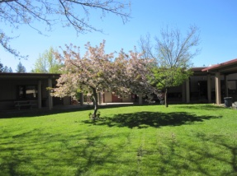
UNION ELEMENTARY SCHOOL
PLACERVILLE, CA
LIBRARIAN: Barbara Lightshoe
April 27, 2011
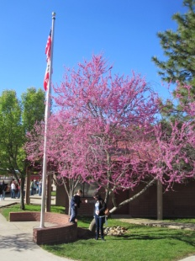
* This was a K – 5 school situated in the beautiful Sierra Nevada Mountains. It was built 20 years ago, the classrooms were a series of one story brick buildings with about 3 classes attached together. The kids hung their coats and backpacks along the walls outside the rooms. There were walkways with trees, flowers, lawns, and a vegetable garden.
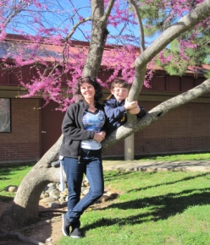
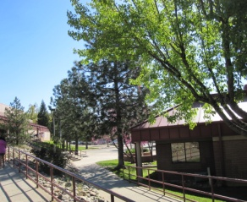

* The librarian was warm, personal, and informed. She was an assistant with assigned classes of ½ hour each. She read them a story and they checked out books (using an old Spectrum version). If a class had an enrollment of 26 or more, she had half of the class at a time. While I was there, the classroom teacher seemed to be the one in charge.
* There was no money for a library budget. The only money available was from two book fairs.
* Actually, there were no art, music, or physical education teachers in any of the elementary schools. The classroom teachers must supplement all these subjects.
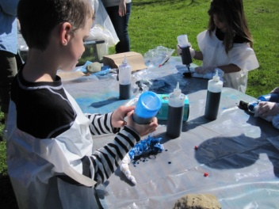
* I will say that this was my favorite school. My friend’s son was in grade 1 and we saw them do a tie dye project on one of the lawns.
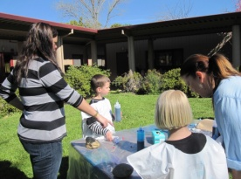

SIERRA ELEMENTARY SCHOOL
PLACERVILLE, CA
LIBRARIAN: Vicki Braussard
April 27, 2011
* This is K – 5 elementary school with an enrollment of 570. It was older than Union Elementary but the outside scenery is so beautiful it didn’t seem to matter.
* This 9-11 tribute caught my eye as I walked into the school:
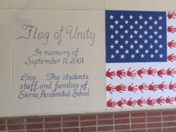
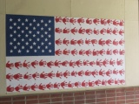

* I have a friend who worked in the office and she was our tour guide.
* I did notice that the people who worked at both the Placerville schools were happy, everyone was just happy and pleasant.
* Vicki Braussard has been an assistant in the library for the past 11 years. When she started her book budget was $13,000, now it is $600. For the last 9 years, she and her library colleagues have to go to speak to the Board of Education administrators and plead for them not to close the libraries. Every year it is threatened that the libraries will either close or the hours of operation will be cut in half. She stated that she is worn out from this appeal process every year.
* An interesting situation is that there is one main Board of Education over the county. Then there are District Boards of Education over various schools. The Sierra School was in a district of 3 schools, another had 4, another had only 1…..totaling 15 District Boards of Ed. Each and every one of these ‘districts’ had a superintendent, assistant superintendent, CFO, and various administrative positions.
* Mrs. Braussard was actually known as Mrs. Book by the students. She has 22 half hour classes a week. She was reading the students Clever Jack Takes the Cake when I arrived and the kids were enthralled.
* Alexandra is their OPAC system and there were 2 computers in the library.
* The school had a beautiful outdoor classroom, I guess opened to whatever class wanted to use it.
